MACHINE LEARNING CHECKPOINT 2

Problem Setting:
The project aims to develop a machine learning model that predicts airline ticket prices based on flight parameters. Indeed, flight ticket prices vary for a number of reasons, such as airline strategies, seasonality, departure times, and demand for a particular route. Such a predictive model would help in giving travellers a good basis for booking decisions and help airlines in their pricing strategies. It can be considered a predictive modelling problem in which not only regression is enforced but also pricing dynamics and non-linear ticket price trends have to be dealt with simultaneously. Thus, various supervised learning algorithms will be considered, such as Random Forest, XGBoost, and Neural Networks, to obtain the best model for the final price prediction.
Methodology:
Framework Overview:
The framework implements a structured pipeline for flight price prediction that starts with Data Loading, i.e., raw dataset collection. Data Exploration is then performed to understand the data's structure and identify possible issues. Data Cleaning turns to missing values, outliers, and other inconsistencies. With the data clean, Data Visualization is done to gain insights on feature relationships and distributions. Feature Engineering is then applied to create or select relevant features that improve the model performance. The data is made ready for analysis through Data Preprocessing as scaling, encoding, and others fulfill the necessary transformations. Model Training then follows, where various algorithms are applied to train the different models. Prediction is then made after that using the trained model, and the results are assessed through Evaluation with performance metrics. Finally, Model Analysis is conducted to interpret the results, identify areas for improvement, and optimize the model's accuracy.
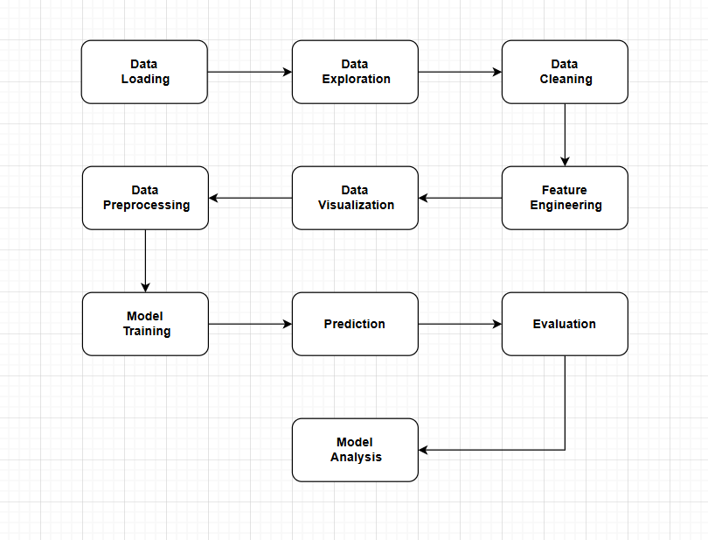

Components of the Framework:
Data Loading - The first step involves acquiring and loading the flight ticket price dataset into the system. This is the foundation for all subsequent steps, where raw data is made available for processing and analysis.
Data Exploration - Once the data is loaded, exploration begins by understanding its structure, identifying patterns, and performing initial statistical analysis. This helps in understanding the dataset's composition and any inherent relationships between features and the target variable (flight prices).
Data Cleaning - Data cleaning follows exploration, where any missing values, duplicates, or inconsistencies are handled. This step ensures that the data is accurate, reliable, and free from errors that could affect model performance.
Data Visualization - After cleaning, data visualization is performed to identify relationships between variables and understand trends in flight prices. Visualizations such as scatter plots, histograms, and heatmaps are used to explore correlations and identify any patterns that might inform feature engineering.
Feature Engineering - Feature engineering involves creating meaningful new features from the existing data. For example, extracting features like travel duration, number of stopovers, and seasonal variations helps improve the model's predictive capability by providing relevant information that may influence flight prices.
Data Preprocessing - Data preprocessing follows feature engineering, where categorical features are encoded (e.g., using OneHotEncoding), and numerical data is normalized or standardized. This ensures that the data is in a suitable format for machine learning algorithms.
Model Training - The next step involves applying different machine learning algorithms to the preprocessed dataset in order to train the model. Various techniques, such as linear regression, decision trees, and ensemble methods, are implemented to predict flight prices.
Prediction - After the model is trained, it is used to make predictions on new, unseen flight data. This stage applies the learned model to provide estimates of flight prices based on new input data.
Evaluation - The performance of the model is then assessed using various metrics, such as RMSE (Root Mean Squared Error), MAE (Mean Absolute Error), and R² (Coefficient of Determination). These metrics help in understanding how well the model performs in predicting flight prices.
Model Analysis - The final step involves interpreting the results of the model, analyzing any errors or shortcomings, and refining the model to improve accuracy. This could involve adjusting hyperparameters, retraining the model with additional data, or exploring alternative algorithms.
States: As the machine learning model trains, its "state" evolves. The model learns from the flight price data, and its ability to predict accurately improves. Over time, the model becomes better at capturing complex patterns such as seasonal trends, variations across airlines, and time-based fluctuations in ticket prices.
Environment: The flight price prediction model operates within a Python-based machine learning ecosystem, utilizing libraries such as Pandas, NumPy, Scikit-learn, TensorFlow, and XGBoost for data processing and training. Development takes place in Jupyter Notebooks or cloud platforms. For visualization, tools like Matplotlib and Seaborn are used. When deployed, Flask APIs or cloud services provide real-time predictions to users.

Model Description:
The flight price prediction system relies on machine learning regression models which include linear regression, random forest, XGBoost, and neural network models, whereby historical flight data is analyzed to predict future prices. Here, Random forest or XGBoost are considered the main models because they handle non-linear relationships well and they are robust to overfitting whereas Linear Regression and Neural Network are considered as alternative models. These models are capable of capturing various patterns of pricing influenced by the date, time, and route. The optimization of model accuracy through hyperparameter tuning during the training process must take place. Performance and reliability in making predictions are measured using evaluation metrics such as R² Score, root mean square error (RMSE), and mean absolute error (MAE). Feature importance techniques like SHAP (Shapley Additive Explanations) and LIME (Local Interpretable Model-Agnostic Explanations) can also be applied to increase the transparency and interpretability of the model. This helps identify and explain the impacts of individual features on price prediction and enlightens the user as to why certain prices are predicted, thus building confidence in the system output.

Implementation Details:
Programming tools:
The project is implemented in Python with the help of various libraries, such as Pandas for data manipulation, NumPy for numerical operations, and Matplotlib/Seaborn for data visualization. Scikit-learn is involved in machine learning algorithms and preprocessing, which include models like Linear Regression, Random Forest, and XGBoost. TensorFlow (Keras) will be used for building a neural network. For model interpretability, SHAP and LIME explain the most important features.
Core Algorithms/Pseudocode :
The project fetches, builds, loads, and pre-processes flight price datasets also integrates managing missing values, extracting date/time features, and encoding categorical variables. Several models - Linear Regression, Random Forest, XGBoost, and a Neural Network - are trained to evaluate performance metrics such as RMSE, R², and MAPE. Explanations for model predictions and important characteristics are provided through SHAP and LIME.
Hyperparameters:
Both Random Forest and XGBoost use 100 trees (n_estimators=100) to balance complexity and performance. The Neural Network has two layers with the first and the second layer containing 64 and 32 neurons, respectively, with training defined in epochs of 50 and a batch size of 32. In addition, the training uses the Adam optimizer to speed up the process.
Preprocessing:
Missing data are filled in, and date and time variables are transformed into purely numerical language (for example, day, month, hour). Categorical variables are one-hot encoded. Numerical features are scaled using the StandardScaler. The data set is then split into the 80-20 share of training and test subsets to measure the model's performance.

Evaluation Plan:
The performance of the models will be evaluated using some key metrics that will provide insight into the accuracy and effectiveness of the model. The first measure to be used is the Root Mean Squares Error (RMSE), which stands for the average magnitude of the errors between the predicted and actual values. RMSE being a differential error criterion is found to be more useful in a regression problem-like one. Here, larger errors are penalized to a heavier extent in terms of decline in the model accuracy; therefore, it could be said that RMSE directly relates to model accuracy evaluation. Next, the R² Score or Coefficient of Determination will help in assessing how well the model explains the variability of the target variable in our case, the flight price. The R² score indicates the proportion of variance in the target variable explained by the model; higher values close to 1 indicate a better fit. Last one would be the evaluation of the Mean Absolute Percentage Error (MAPE), which reveals how accurate the model is in predicting the actual values. MAPE gives a percentage figure for the error which is helpful for analyzing the relative error in price forecasts and comparing the performance of different models.
Cross Validation:
This project will evaluate through train-test split, which is a robust technique for model evaluation. The dataset will be divided into training set and test set using the 80-20 ratio where training set forms 80% of the dataset while test set makes up 20%. This method guarantees a fair assessment of model performance on unknown data. K-fold cross-validation is also an alternative method that could be used for better generalization, but the choice here is on the train-test split since it is a simple and efficient method having regard to the size of the dataset and that the work focuses more on evaluating the model.
Challenges and Solutions:
- Overfitting: Various models are used (Random Forest, XGboost, Neural Networks), and the risk of overfitting is present, especially for complex models such as decision trees or neural networks. Overfitting occurs when a model learns the training data excessively well, picking up noise and irrelevant patterns in the process, which leads to poor generalization to unseen data.
Solution: These measures include cross-validation that will ensure that the model does not overly depend on specific training data. Furthermore, early stopping will be employed in the Neural Network model, which will end training when the validation error increases so that it does not learn irrelevant things. Hyperparameter tuning, with respect to tree maximum depth for Random Forests or the number of layers in the neural net, will help keep complexity in check.
- Data Imbalance: Even though data sets about flight prices hardly project highly imbalanced traits, variations in certain categories like airlines or routes could set a target variable (price) astray. In cases where one category is more favoured than another, the model instead will develop a bias towards this frequent category.
Solution: In cases where imbalanced data could affect the model, the methods for treatment might involve some modification in the dataset via oversampling like SMOTE or under sampling. Further, one could also resort to ensemble techniques such as Random Forest and XGBoost, which are more robust against imbalance by nature.
- Model Interpretability: Even advanced models like XGBoost and Neural Networks might provide high accuracy, they are less interpretable.
Solution: SHAP and LIME shall be employed to explain the predictions made by the model concerning the elements that are responsible for ticket price prediction. Transparency in the decision-making process of the model shall thus be ensured so that it becomes understandable to final consumers and gives confidence in its results.

Preliminary Results:

